July 23, 2010

Adam Simmons
23952 Plant Ave
Mission Viejo, CA 92691

RE: 23952 PLANT AV

Dear Adam Simmons,

In an on-going effort to encourage water use efficiency in a fair and equitable manner, El Toro Water District (ETWD) implemented a new Water Budget-Based Tiered Conservation Rate Structure (Tiered Conservation Rate Structure), as of July 1, 2010.

The Tiered Conservation Rate Structure provides an indoor water budget and a separate outdoor water budget. Each budget is calculated based on a variety of individual factors, including occupancy and estimated irrigation area. Inaccurate data will likely result in an inaccurate water budget.

Your last (June) water bill indicates that you exceeded your Tier I - indoor and Tier II - outdoor water budgets. We want to make sure that the information we used to calculate your water budgets is accurate, and to clarify the impact that exceeding your water budgets will have on your monthly water bill. You bill was calculated using the following data:

SERVICE ID  3529228 | OCCUPANCY  4 | IRRIGATION AREA ft²  4110

Please look at the occupancy number and the irrigation area listed above to verify that these figures are accurate. If the occupancy and/or irrigation area of your home is inaccurate, please contact our Customer Service Representatives at 949.837.0660.

The Tiered Conservation Rate Structure is comprised of four tiers of water use and ultimately, four different water rates. To ease the transition to the tiered rate structure, the new rates will be phased in over the next few months, as noted below. The Tiered Conservation Rate Structure is designed to reward customers who use water efficiently and discourage waste. Customers who continue to exceed their Tier I and II budget will pay significantly higher rates.

Water Use Charges | July  2010 | November 2010 | January 2011
Tier I - Indoor | $1.80 | $1.80 | $1.80
Tier II - Outdoor | $2.20 | $2.20 | $2.20
Tier III - Inefficient | $2.20 | $3.29 | $4.38
Tier IV - Excessive | $2.20 | $4.07 | $5.94

We encourage you to utilize all of the available conservation measures to avoid these higher rates. Conservation tips and information on the new Tiered Conservation Rate Structure are available on our website at www.etwd.com or by calling Customer Service at the number above.

Sincerely,
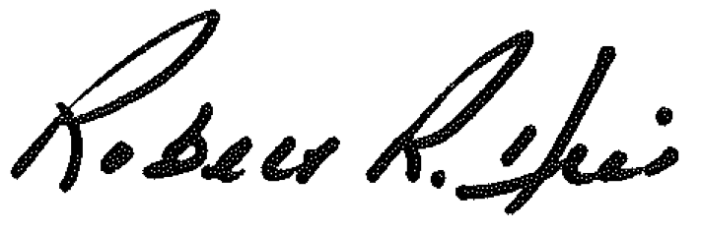

Robert R. Hill
General Manager

